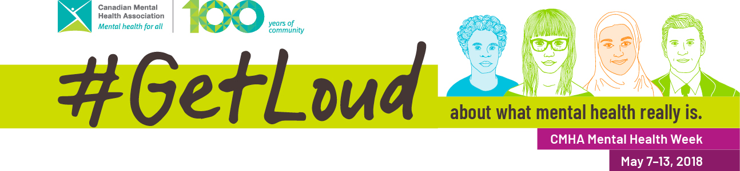
Mental Health Week Social Media Banks
Mental Health Week Pre-Promotion Social Posts
1 in 5 Canadians experience a mental health issue in any given year, but ALL Canadians have #MentalHealth. Get ready to #GetLoud for CMHA #MentalHealthWeek May 7-13! www.mentalhealthweek.ca
There is more to mental health than mental illnesses. Get ready to #GetLoud this May 7-13 for CMHA #MentalHealthWeek! Learn more at www.mentalhealthweek.ca
Being mentally healthy means you feel good about life, you’re reaching your potential and you’re accomplishing your goals. Get ready to #GetLoud about what mental health really is May 7-13! www.mentalhealthweek.ca
#MentalHealth is an important part of health. Get ready to #GETLOUD May 7-13 for CMHA’s 67th Mental Health Week! www.mentalhealthweek.ca
We can all improve our #MentalHealth, just like our physical health. Get ready to #GETLOUD May 7-13 about what mental health really is. #MentalHealthWeek www.mentalhealthweek.ca
#MentalHealthWeek is just around the corner! Get ready to #GetLoud about what #MentalHealth really is. It’s about everyone’s well-being. Learn more: www.mentalhealthweek.ca
#MentalHealth is everybody’s issue! Are you ready to #GetLoud about what mental health really is? Learn more about #MentalHealthWeek at www.mentalhealthweek.ca
When we’re mentally healthy, we enjoy our life and the people in it. Get ready to #GetLoud about what mental health really is this May 7-13! #MentalHealthWeek www.mentalhealthweek.ca
Mental health is worth protecting, celebrating and promoting. Join us May 7-13 and #GETLOUD about what mental health really is! #MentalHealthWeek www.mentalhealthweek.ca

Mental Health Week Social Posts (May 7-13)
#MentalHealth is about more than having a #Mentalillness or not! We ALL have a state of mental health! #GetLoud with us for #MentalHealthWeek about what mental health really is www.mentalhealthweek.ca
This year for #MentalHealthWeek, we’re getting even louder in support of #MentalHealthForAll. Join us and #GetLoud about what mental health really is! www.mentalhealthweek.ca
This week is #MentalHealthWeek, and we’re asking you to #GetLoud about #MentalHealth! Check in on your #MentalHealth with our checklist mentalhealthweek.ca/check-in-on-your-mental-health
For #MentalHealthWeek, why not check in on your own #MentalHealth? mentalhealthweek.ca/check-in-on-your-mental-health/ We ALL need to keep our #MentalHealth in mind. Join us and #GetLoud this week about what mental health really is.
We all have a state of mental health, whether or not we have a mental illness. #GetLoud with us this week about what mental health really is! #MentalHealthWeek www.mentalhealthweek.ca
You might feel well sometimes, and sometimes not. It’s all about your mental health. #GetLoud this week about what mental health really is #MentalHealthWeek www.mentalhealthweek.ca
We ALL need to think about our mental health, just as we think about our physical health. Help us #GetLoud about what mental health really is! #MentalHealthWeek www.mentalhealthweek.ca
Diet, exercise and rest – they impact your mental health, just like your physical health! #GetLoud about what mental health really is this #MentalHealthWeek www.mentalhealthweek.ca
#MentalHealth affects our thoughts, our feelings and the things we do. #GetLoud about what mental health really is for #MentalHealthWeek www.mentalhealthweek.ca
Your #MentalHealth: protect, promote and celebrate it. #GetLoud about what mental health really is for #MentalHealthWeek. You can learn more at www.mentalhealthweek.ca

